

NOVAC TECHNOLOGY SOLUTIONS

User Manual

Document Version No.: 1.00

Revision History
Version No | Reason For Changes | Author | Approver
0.01 | Draft | Vinothini S
1.00 | Reviewed & Approved the User Manual | Vinothini S | NIJANTHAN PL

Table of Contents
1. Introduction 4
2. GPA RFQ 4

Introduction

The document is prepared to understand and build an application for Group Personal Accident Insurance to the insured.

GPA RFQ

- The users should be allowed to select the PA for an Individual person.
- Post selecting the Group Personal Accident Insurance policy in the ZIVA Application, the user will be allowed to capture the Insured details
- Post capturing the Policy details, the user will be allowed to capture the Insured details, Risk details and Add on cover details.
- Post successfully capturing all the above-mentioned details, RFQ will be generated by clicking Generate quote. The generated quote can be downloaded from the RFQ screen.
- Post successfully generating the quotation, the quotation can be converted to proposal. We will get a proposal number accordingly.
- Once the Proposal number is generated and the debit note is successfully generate, the Policy will be generated.

Path: PA proposal -> PA Proposal Dashboard
Screen Code: S0536

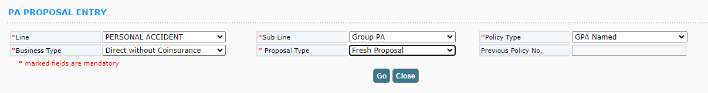

After selecting the sub Line and policy type details, on clicking Go button, remaining fields to capture the proposal details will be displayed.

For GPA Named product, user have to upload the member details using the upload button. After successful upload user can calculate the premium and generate the RFQ. If upload fails on clicking view button user can view the validation message and correct the details in excel and again upload.
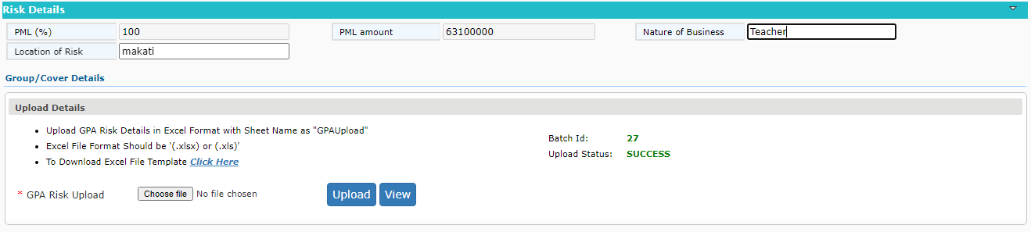

For unnamed product, excel upload is not applicable. So user has to enter the group details.

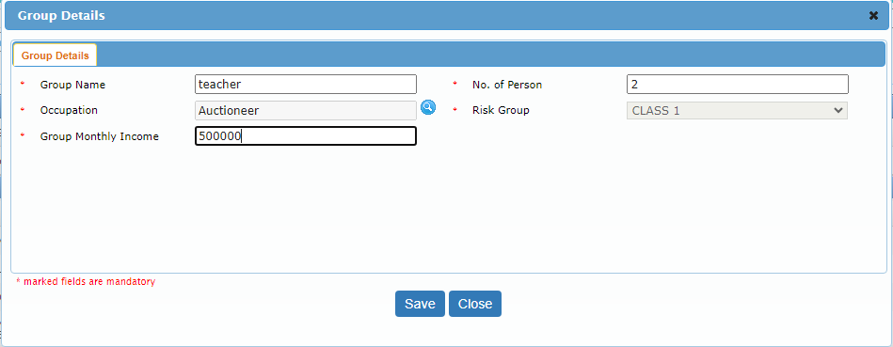

Cover details as same as IPA.

